User manual

The user is first presented with two options of whether to create something or to quit.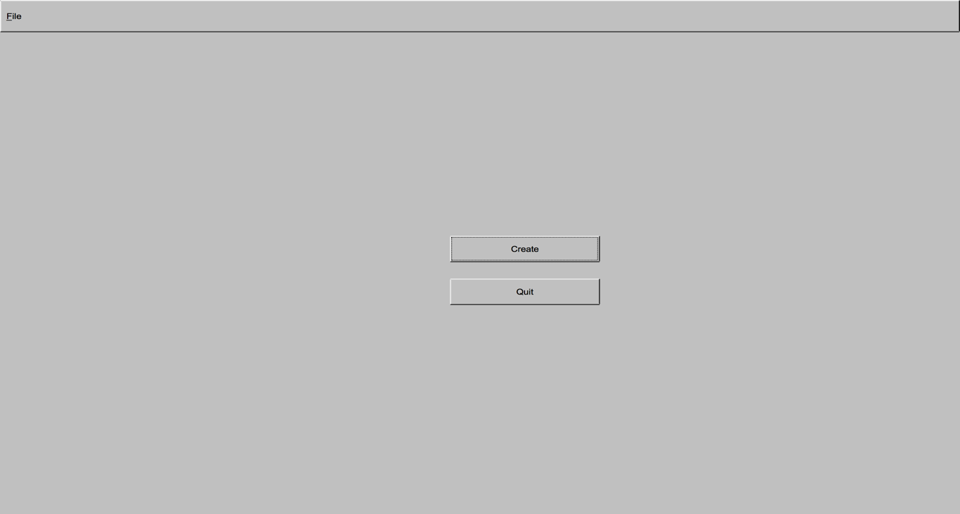

If the user quits then the program exits; however, the more preferred route is if they chose to create something in which case it takes them to the screen below

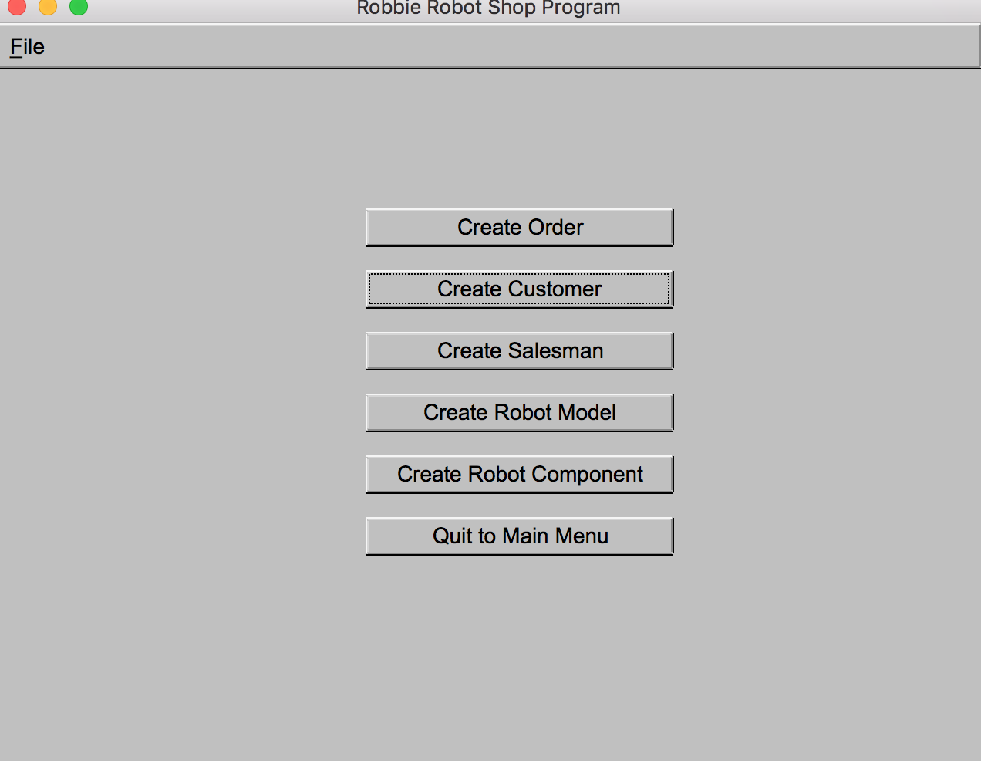

This screen gives a variety of options all of which are very self-explanatory by their representative buttons. The only catch is that you cannot create an order until all of the other activities have finished. This will display a warning if you try to do so. The pictures below will show you what each screen would look like if you ran through the program.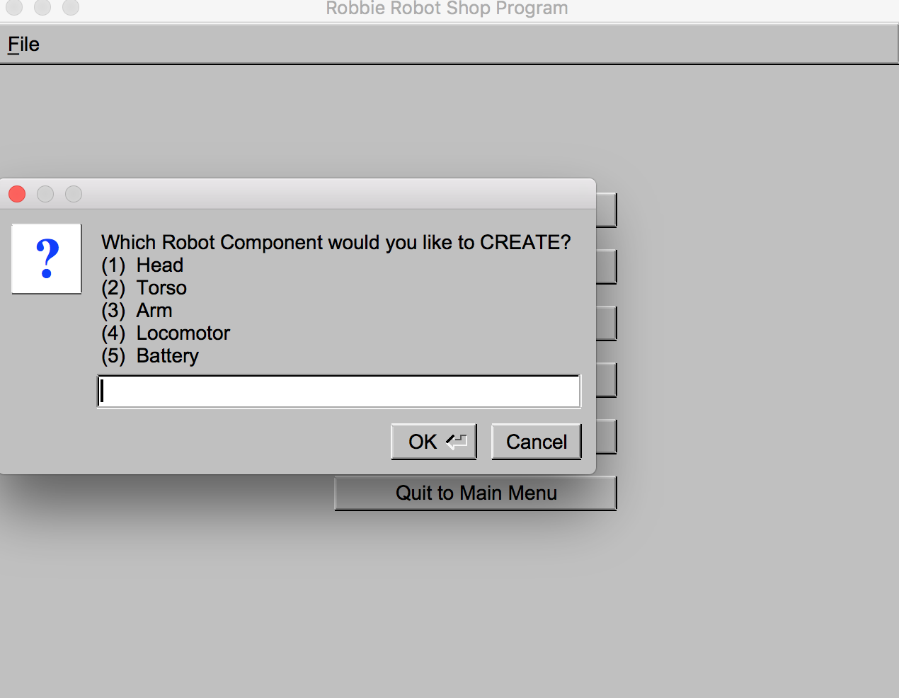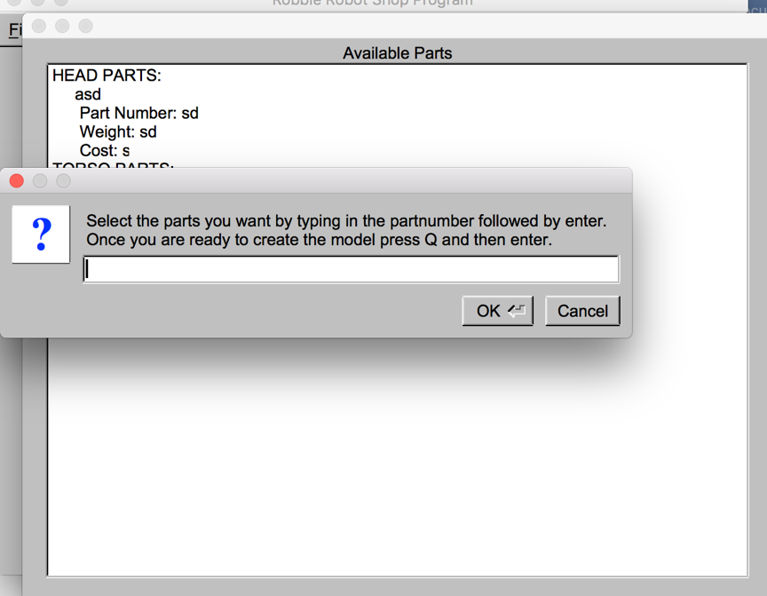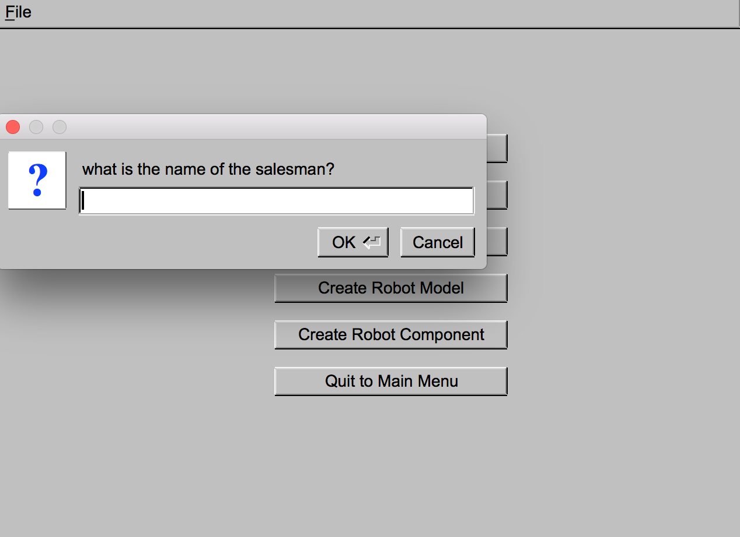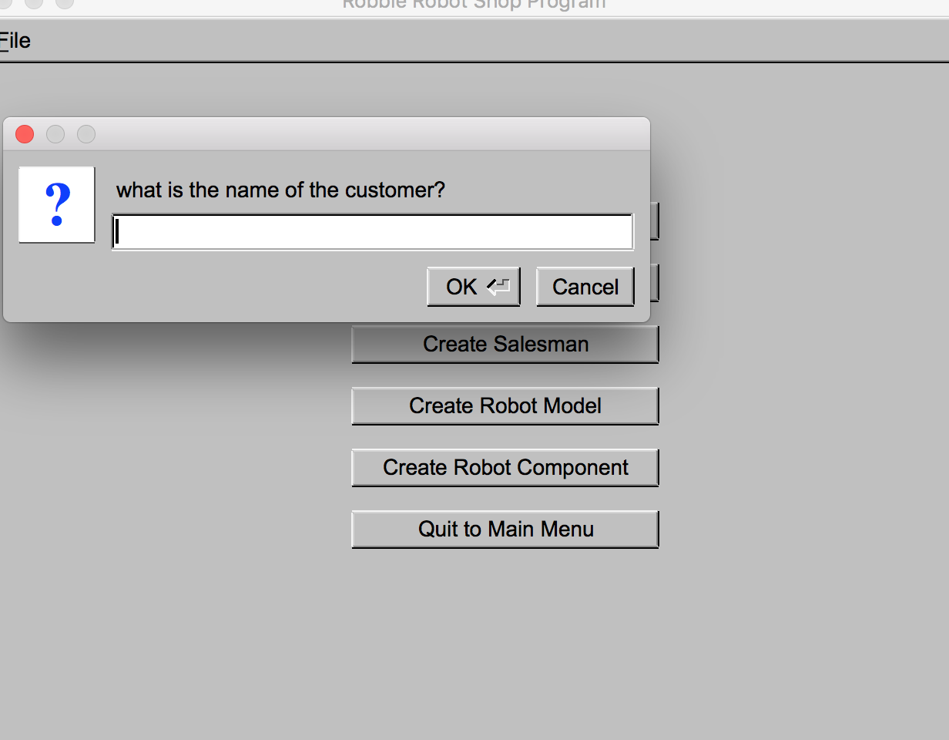

The end goal of the program is to create a robot part which will then lead to the creation of a robot model and then be able to sell that model to a beloved customer.